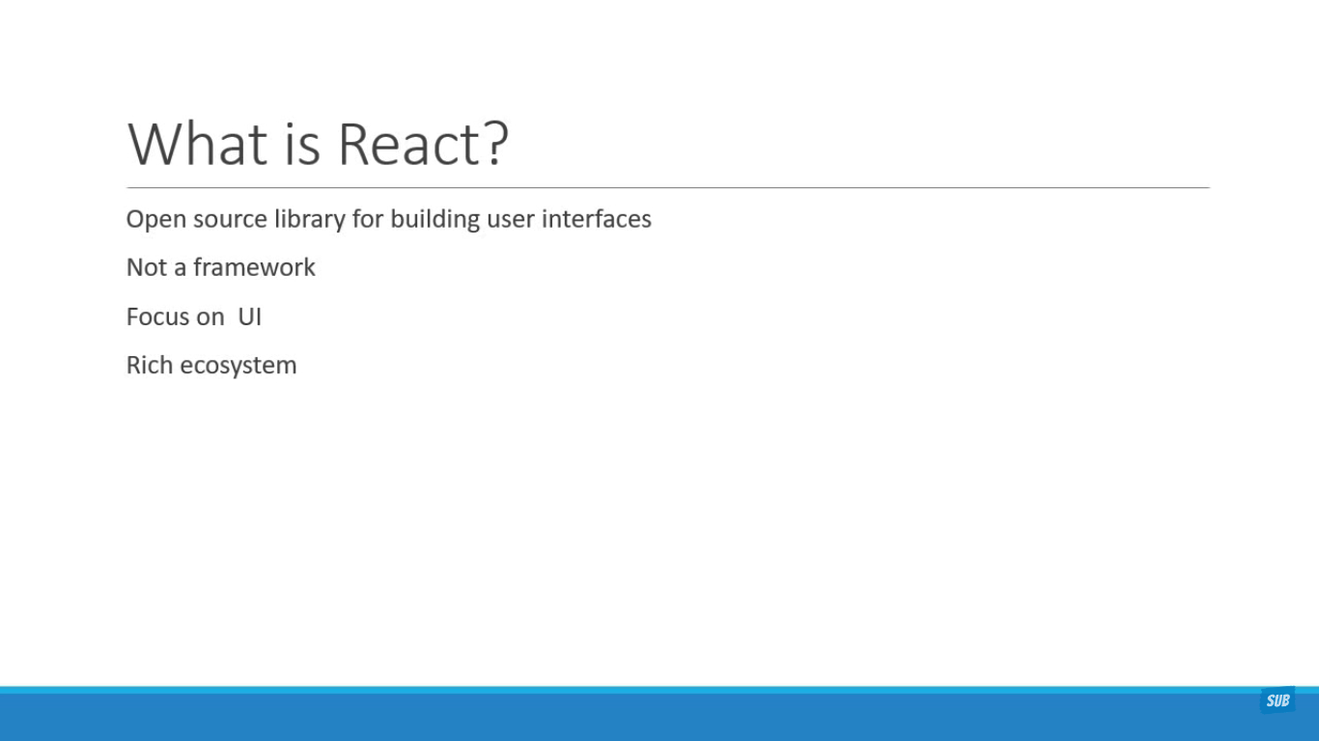

1. Why React?

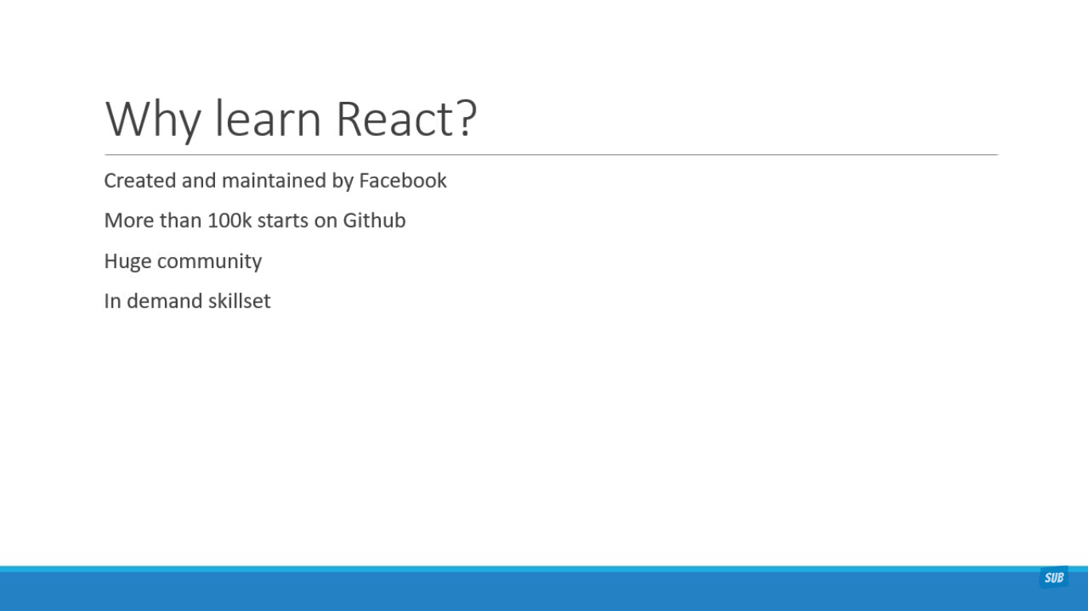

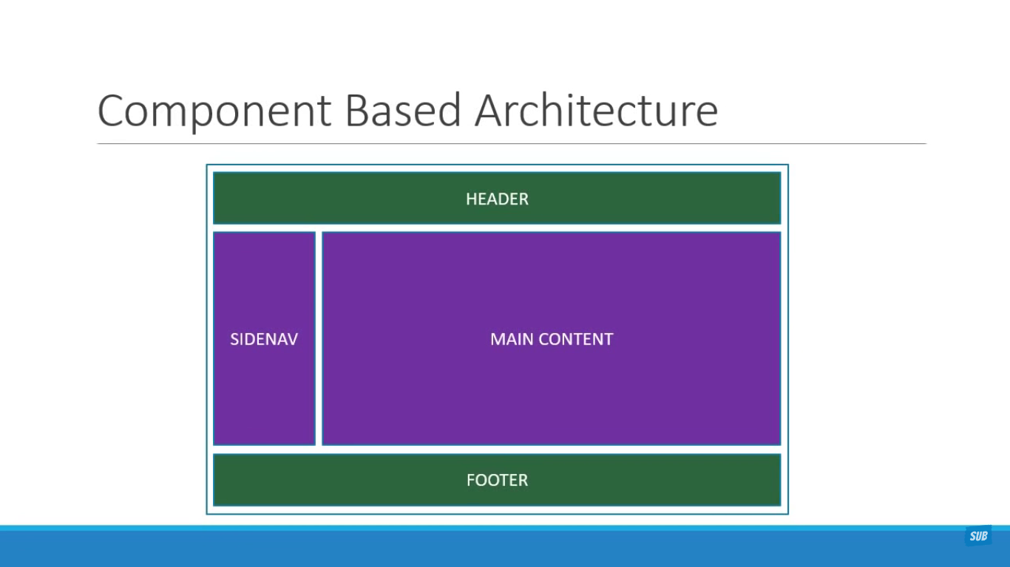

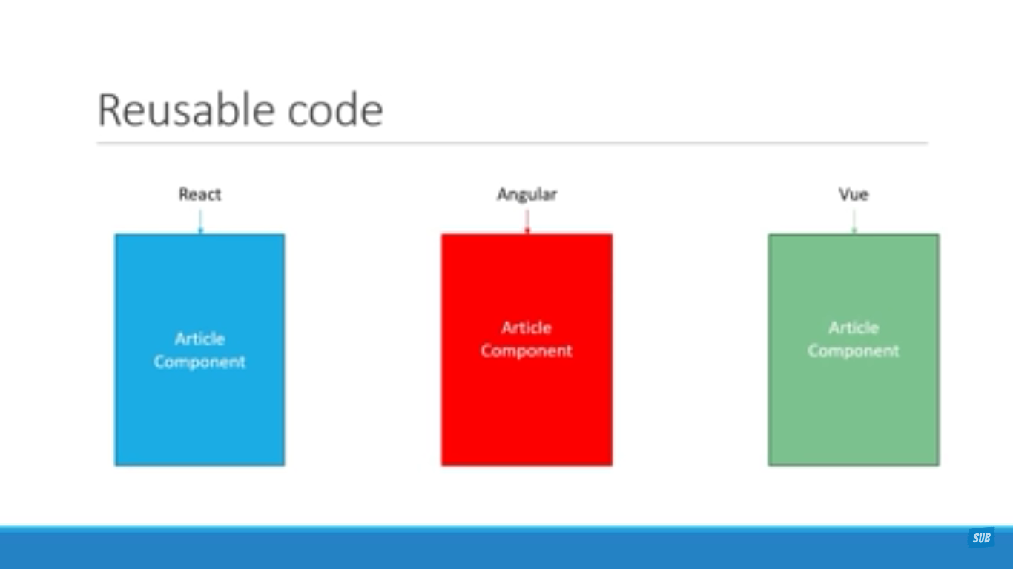

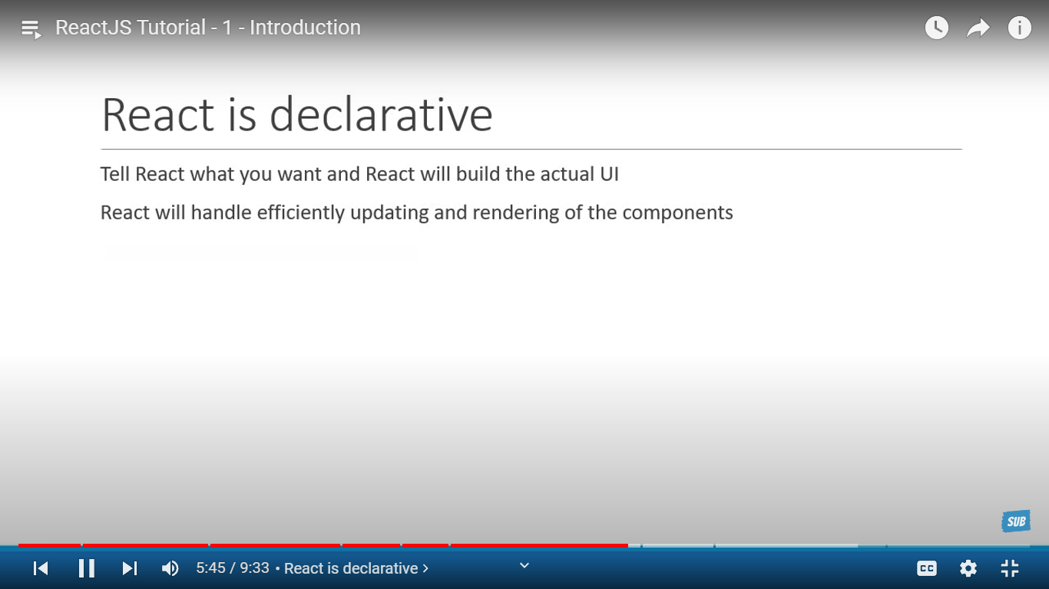

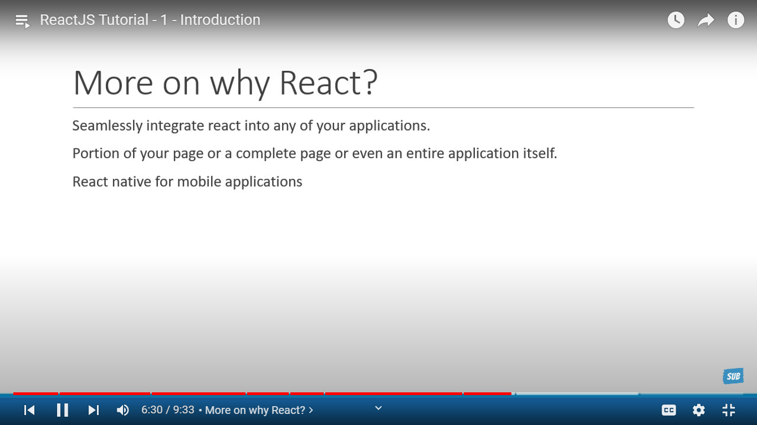

1. Required topics to start React

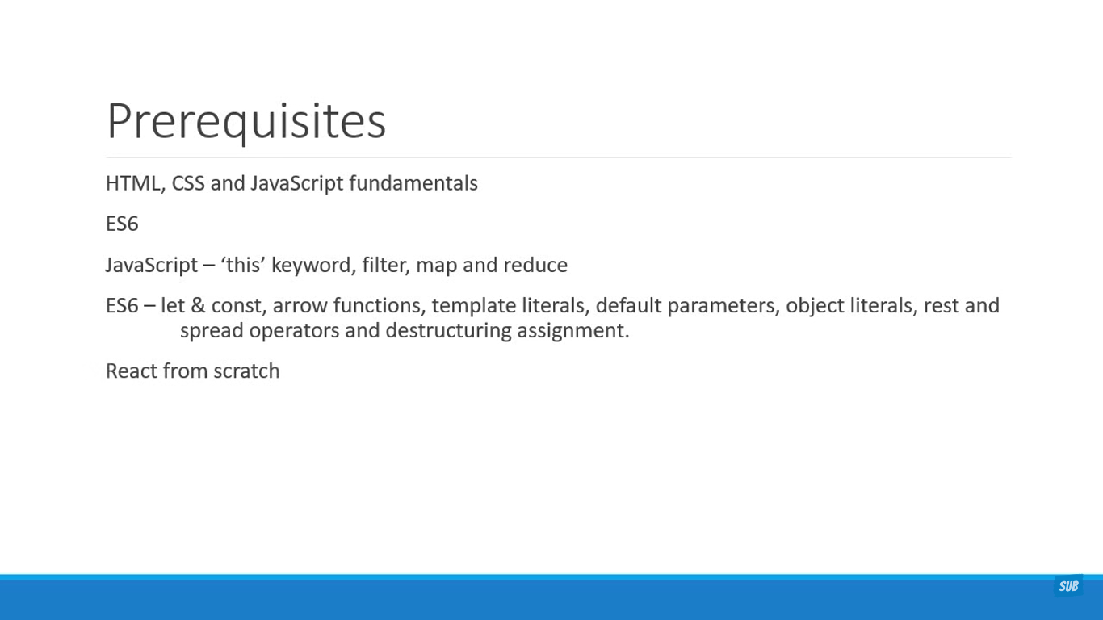

1. Topics covered in this Course

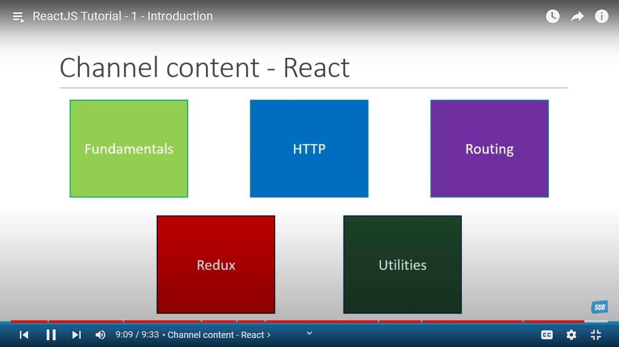

1. Create React app Npm vs Npx

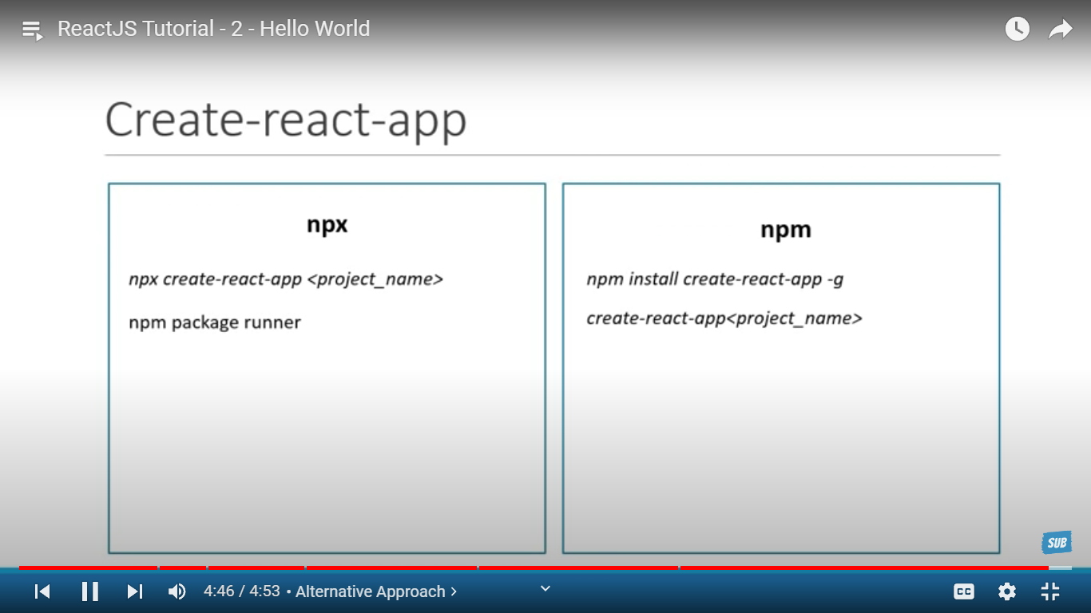

1. Real DOM V/S Virtual DOM

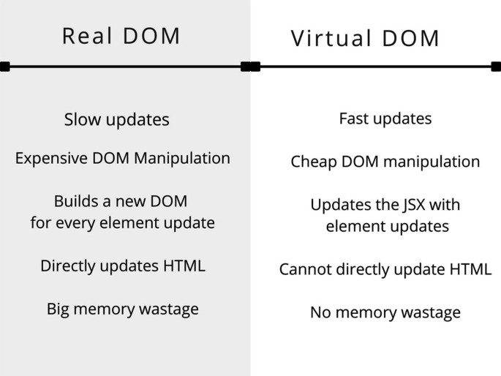

1. Stateless Functional VS statefull Class Component

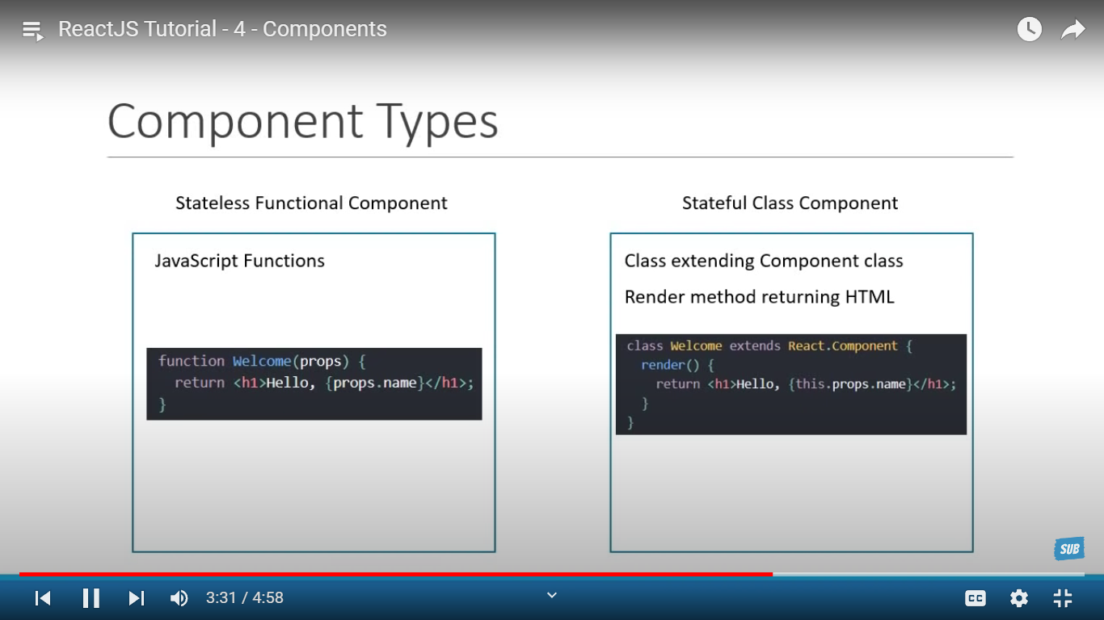

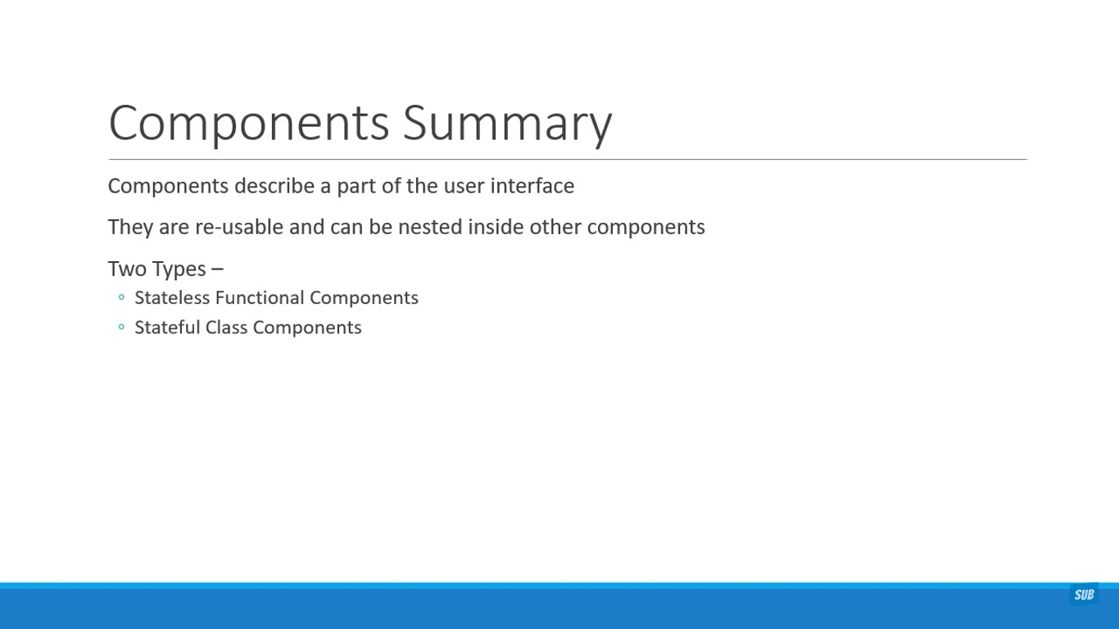

Functional Component:

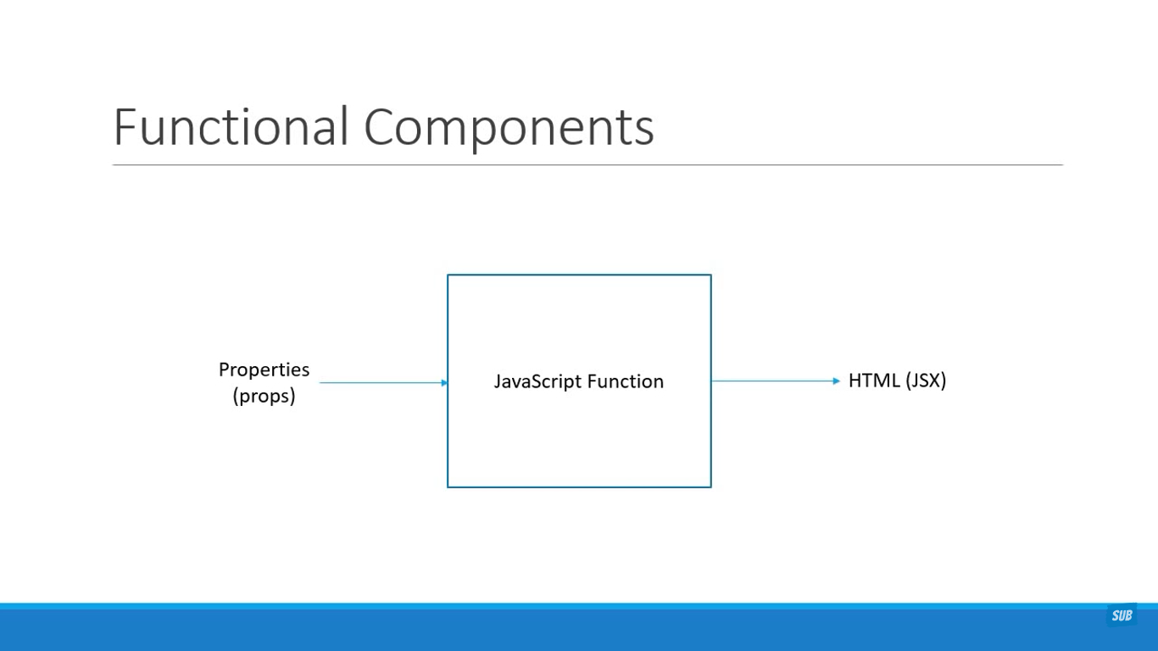

Class Component:

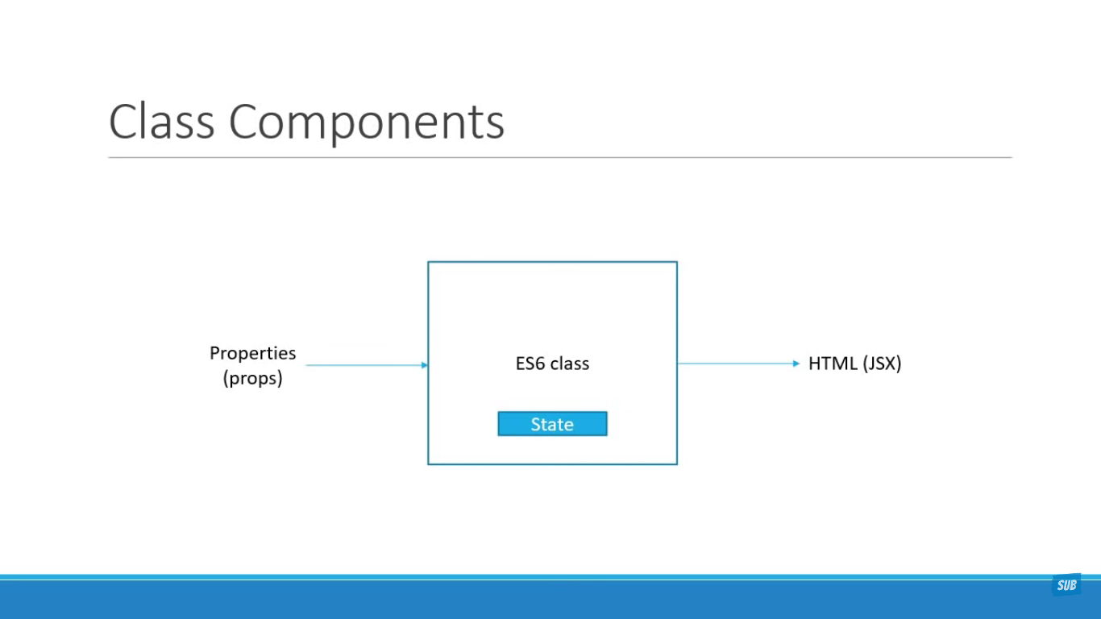

Functional v/s Class Components:

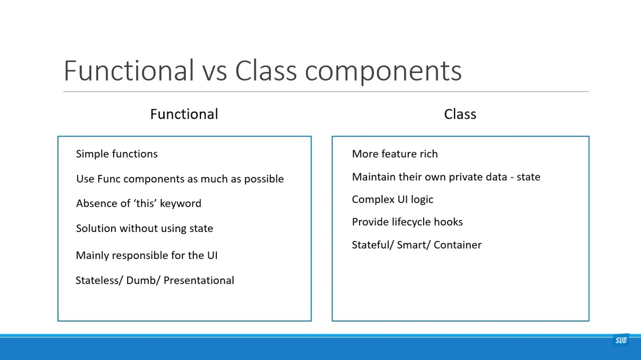

**Controlled v/s Uncontrolled Components:**

| **Features** | **Controlled Component** | **Uncontrolled Component** |
| --- | --- | --- |
| Value Management | Managed by React state | Managed by component's own internal state |
| User Interaction | Parent component updates state on user interaction | Component updates own internal state on user interaction |
| Data Flow | Data flows from parent component to component | Data flows within the component |
| Debugging | Easier to debug | More difficult to debug |
| Performance | Generally faster as there's less state management | Generally slower as there's more state management |
| Code Complexity | Less complex code | More complex code |
| Best Practices | Considered a best practice | Considered an alternate approach |

JSX:

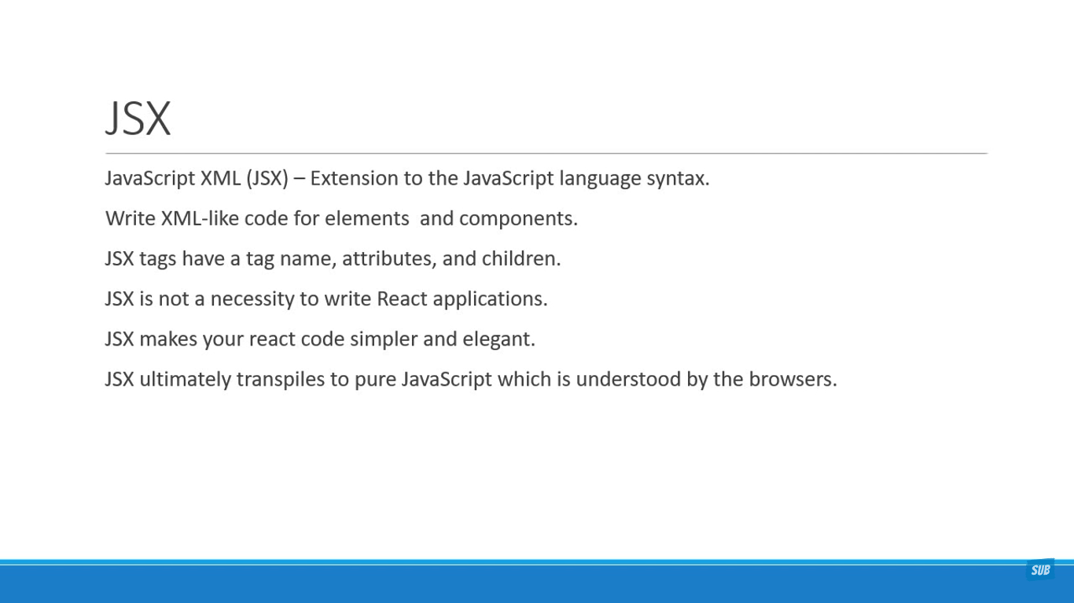

With JSX:

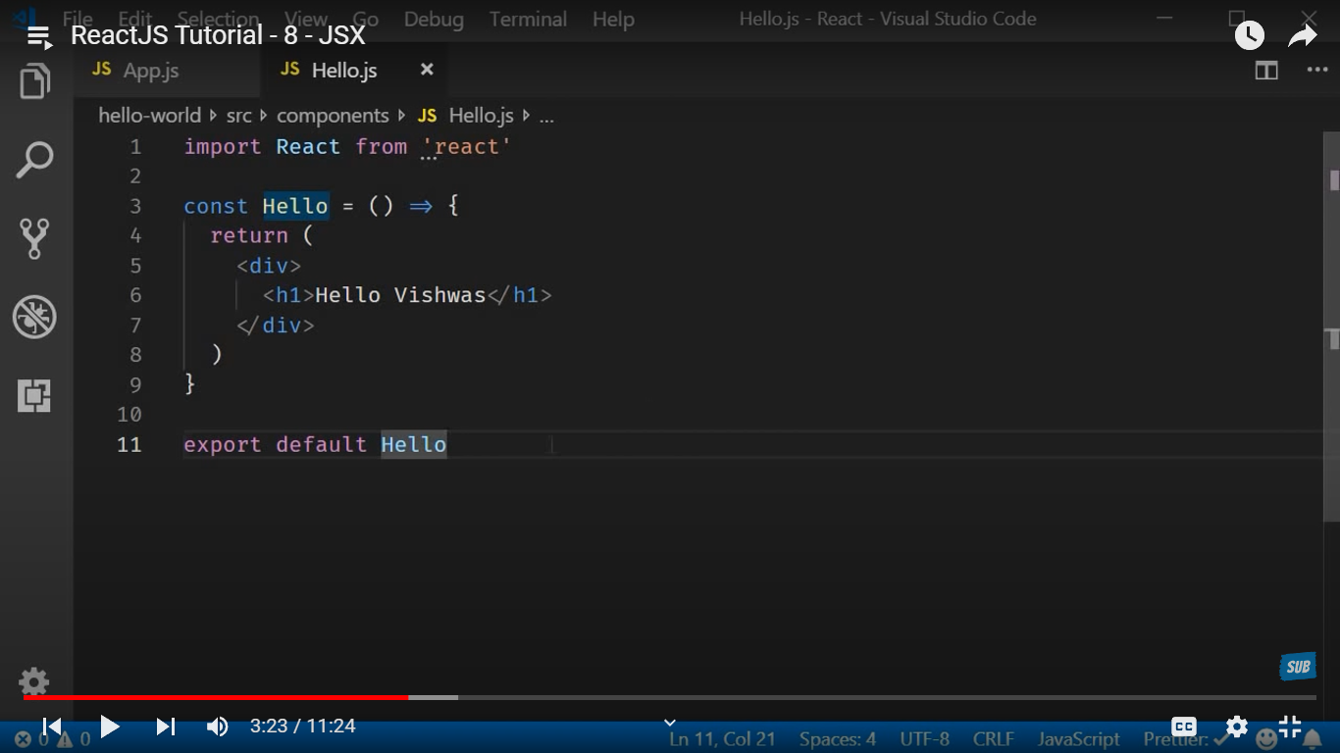

Without JSX:

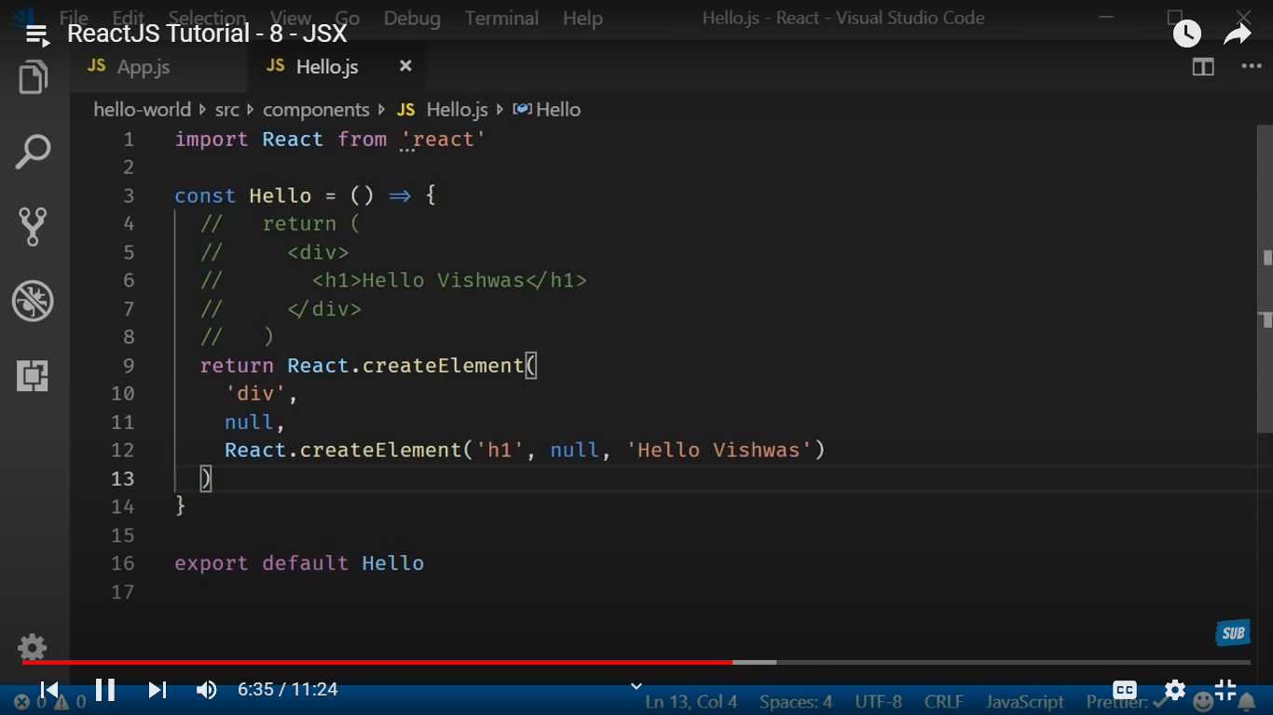

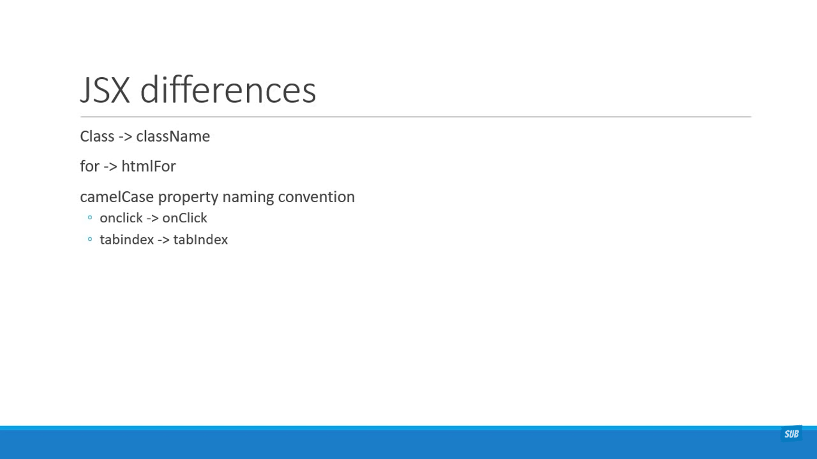

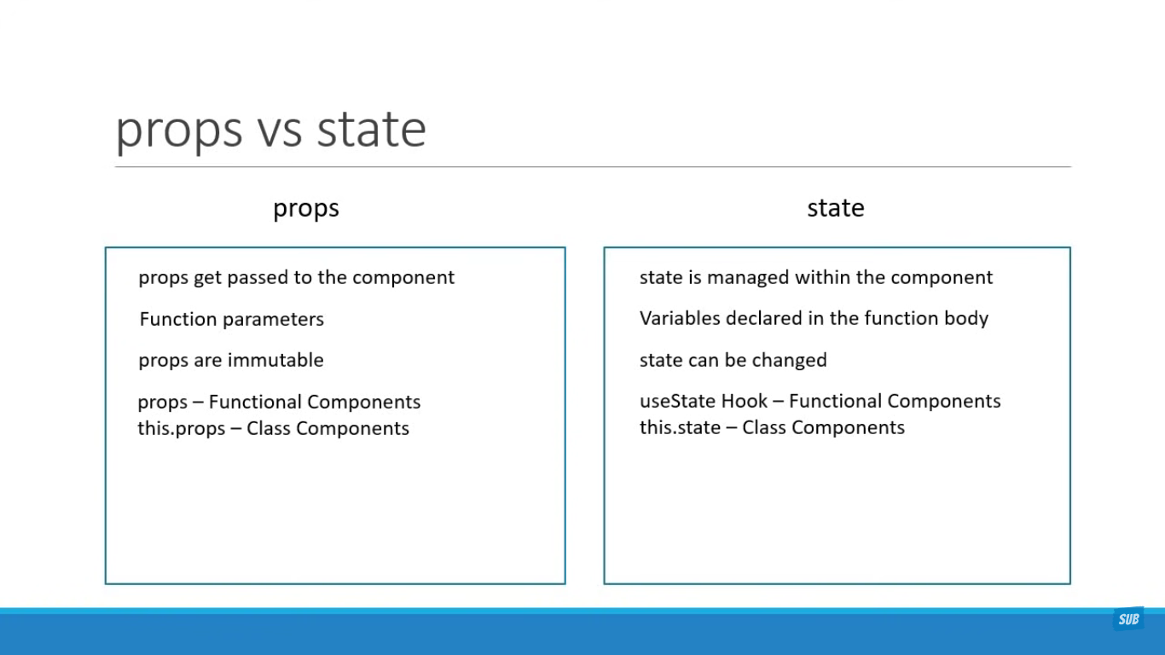

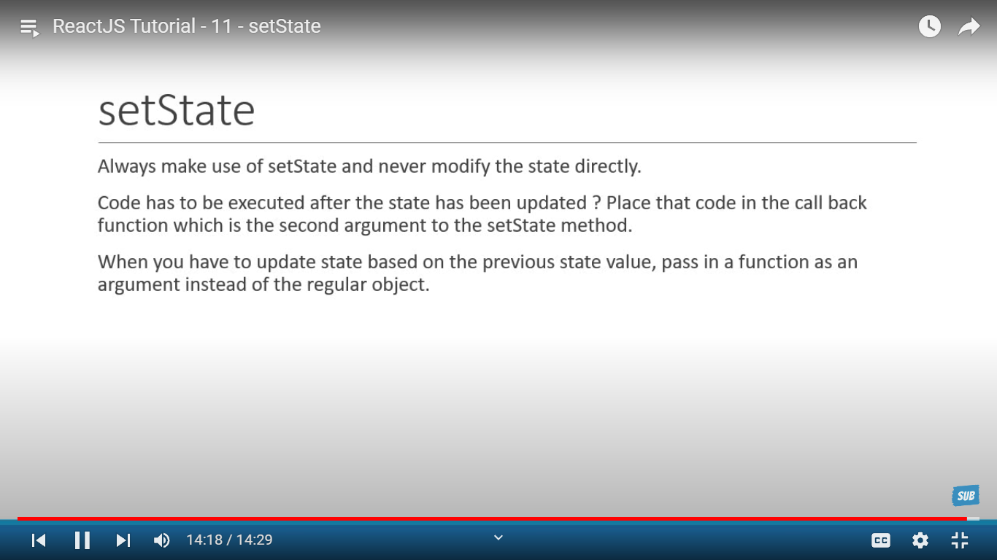

Why binding:

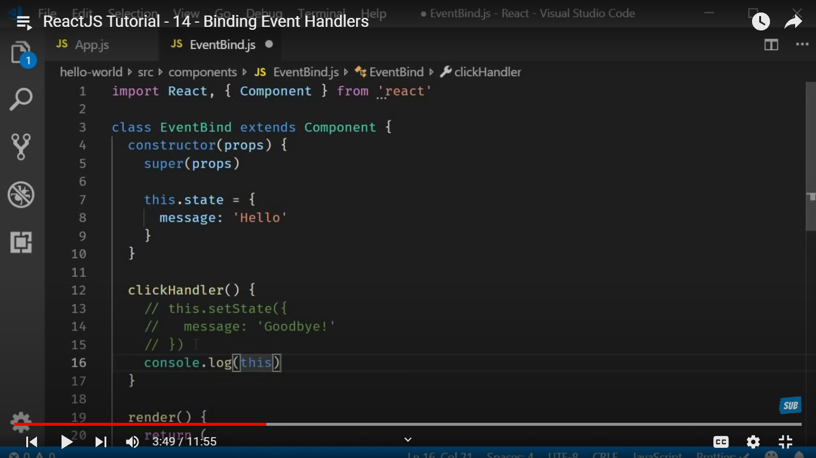

🡪 In below screenshot onclick of button we can see Undefined is logged in console.  
this is why we need to bind.

* ‘’this’’ keyword is undefined in event handler that’s why we need to bind events in react  
    
    
  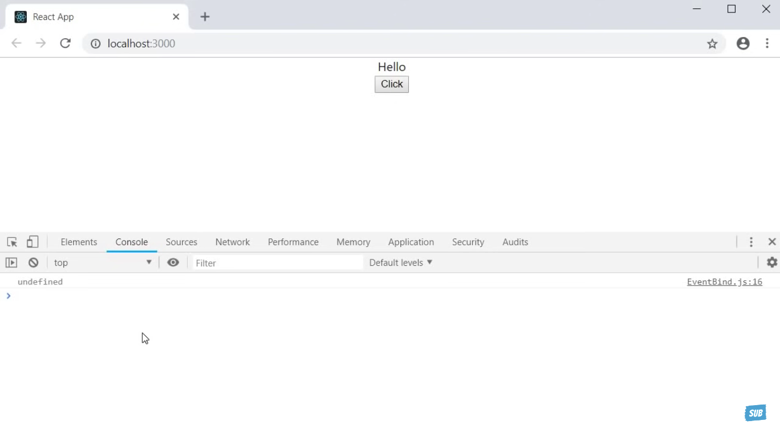

this.clickHandler = this.clickHandler.bind(this) – this is the best way to bind the events in react

Lists and keys:

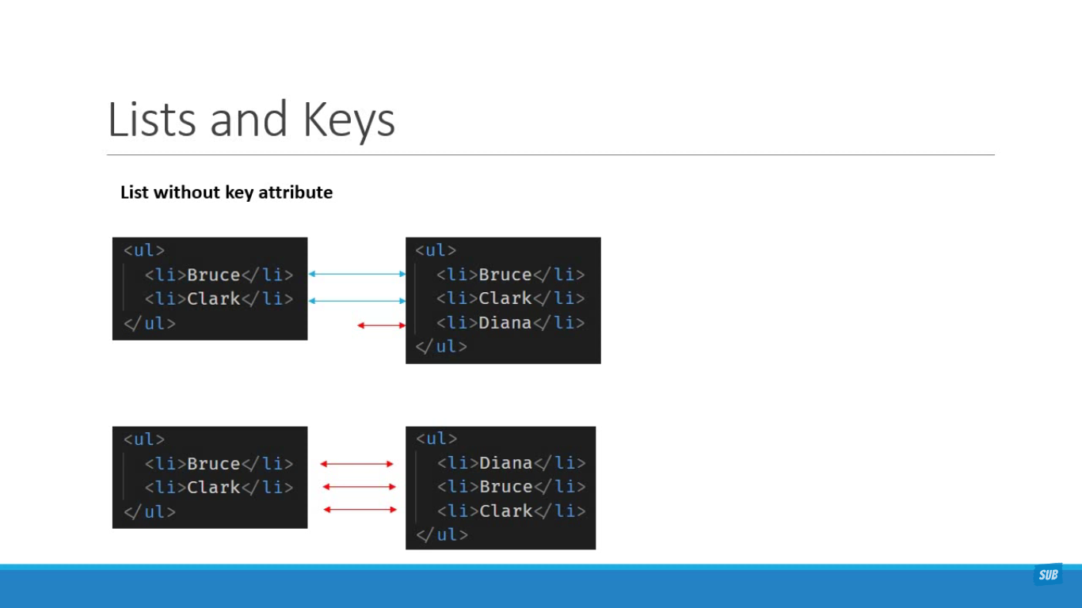

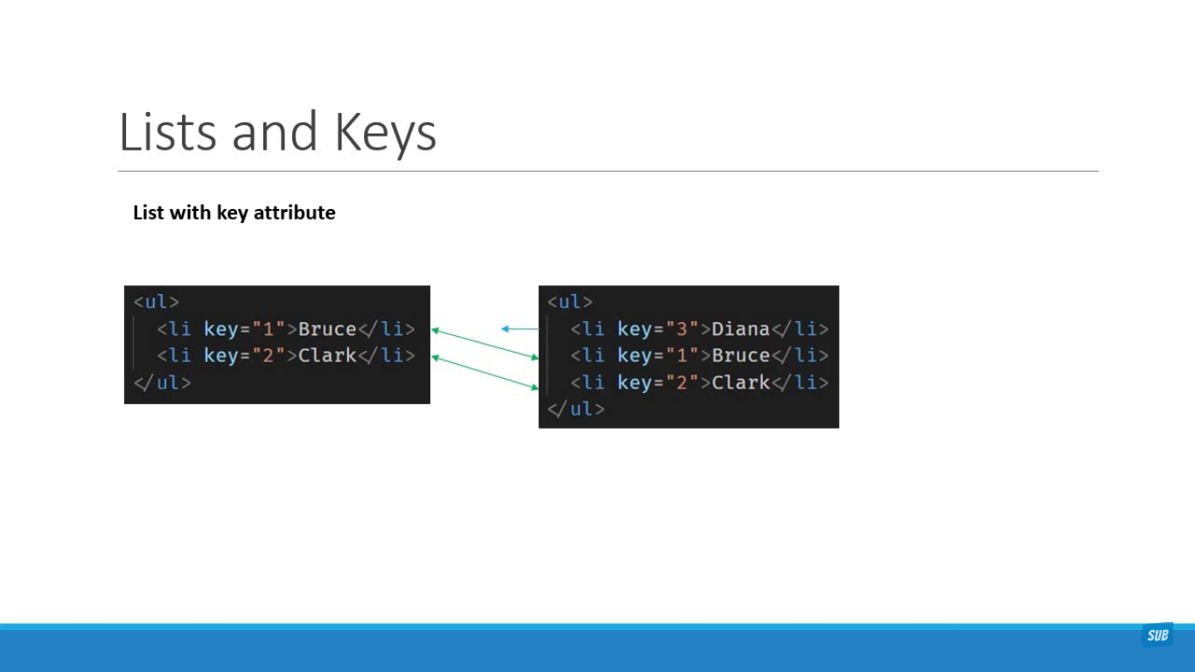

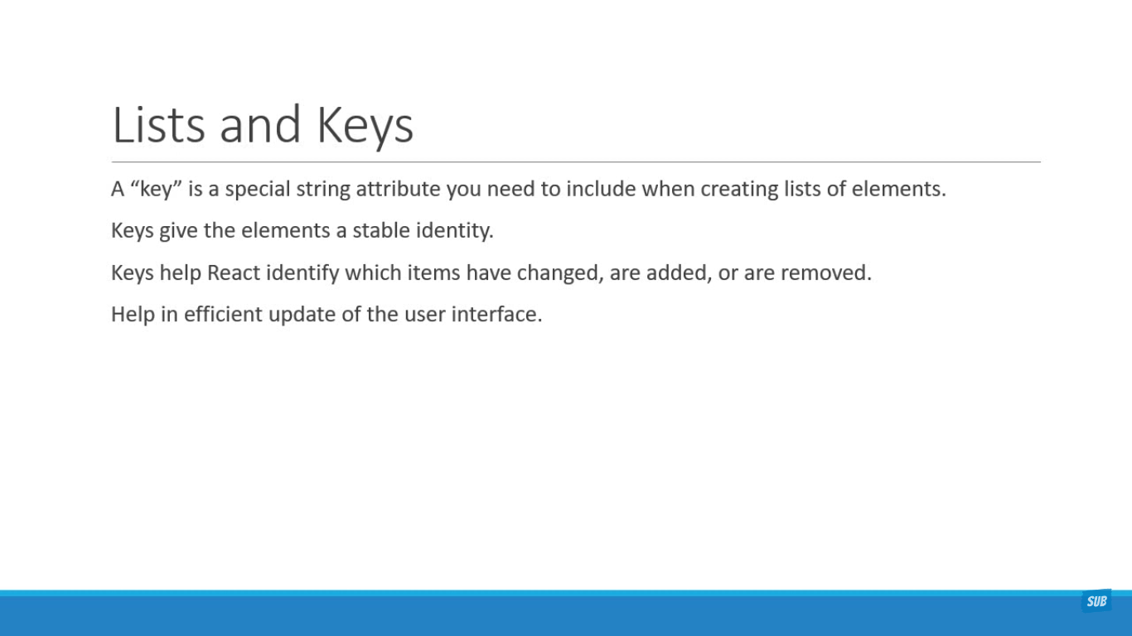

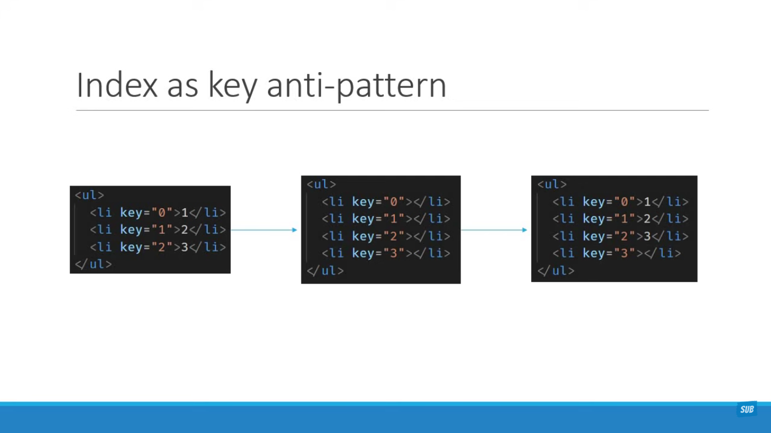

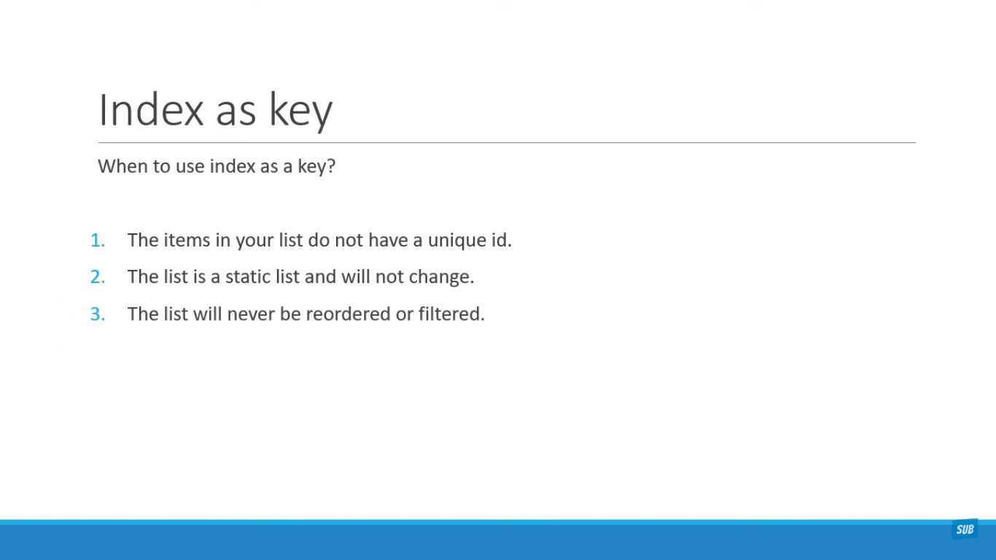

Pure Components

